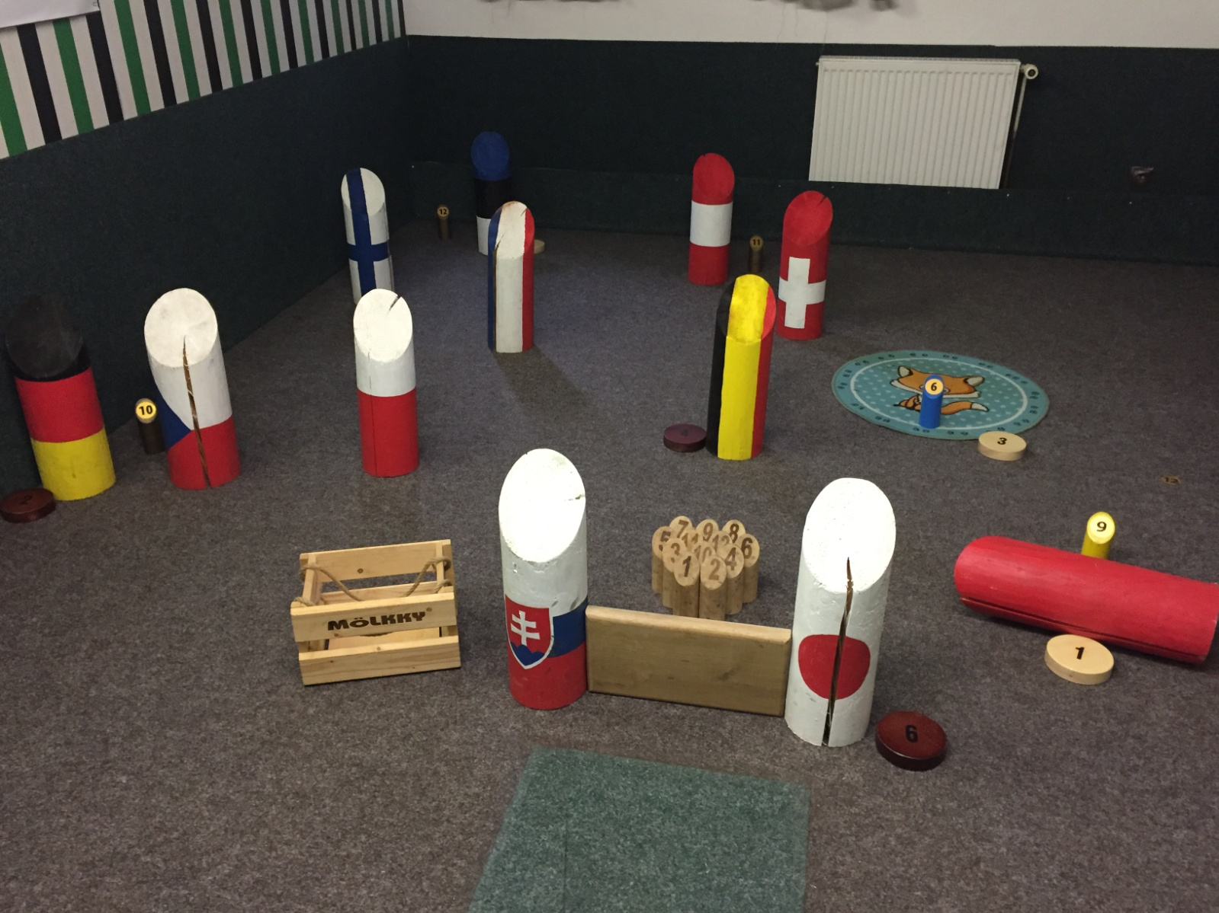
Gate arena, Zruc nad Sazavou, Sad miru 1055
22. – 23. 02. 2020
Friday 18:00 presence, trainings
Saturday 10:00 qualifications, first rounds
and 1. round of play off
Sunday 10:00 quarterfinals, semifinals, finals

schedule, registrations (till 9. 2. 2020) and informations:
www.zazrucveselejsi.cz www.euromolkky.cz

World Championship in MÖLKPARKOUR SCHEDULE
Venue: Gatě aréna, Sad míru 1055, 285 22 Zruč nad Sázavou, 777 922 395, carpet
Date of event: Friday – Sunday 21. – 23. February 2020
Organizer: SKM Zruč nad Sázavou – TENNISLINE, z. s.
Organizing committee: Leoš Fiala 777 922 395, Pavel Mácha 727 804 494, Mária Fialová 724 327 778
Registration and informations: via e-mail to leos.fiala@volny.cz or SMS to 777 922 395, applications
must include participant´s full names and dates of birth, the
deadline for each competition is 9.2. 020 at 24:00, starts max. 40 players
Draw: the draw of all competitions will take a place on Tuesday 11.2.2020 at 19:05 in a clubhouse of SKM Zruč and will be published on www.euromolkky.cz website on Thursday 13.2.2020
Competitions: singles, couples, teams (3 players, + max. 1 alternate)
Starting fee: 200 CZK or 8 Euro for each player, bank account SKM Zruč 554070/5500, v. s. 210220, indicate the name of the player or the team, it is possible to pay also cash at the registration
System: each player will complete 3 rounds (6 throws each) in qualification, two best
scores will count to all competitions, play off will be deployed according to the
results from qualification
Obstacles: 1. čínská zeď/chinese wall/kiinan muuri – throw, mölkka no. 9 is placed at a distance of 3,75 – 4 m in width of mölkkys behind the obstacle of 160 mm
height
2. průsmyk/pass/sirtää – vypich, mölkka no. 10 is placed a distance of 3,75 – 4
m behind two obstacles situated apar in width of mölkkys
3. lišák/dog-fox/koira-kettu – technical throw, mölkka no. 6 is placed in front part
of the target with diameter of 60-70 cm, if the mölkka or the throwing pin stays in the larger half of the target, player gains another 3 points
4. tři duby/three oaks/kolme tamea – long throw, mölkka no. 11 is placed at a
distance of 6 m and s covered with 3 obstacles
5. koridor/corridor/käytävä – long throw, mölkka no. 12 is placed at a distance
of approx. 6,2 m, pin´s track is set up with 4 obstacles
6. francouzské okno/french window/ranskalainen ikkuna –12 mölkkas are placed
in a basic position 25 cm behind an obstacle of 40 cm width 25 cm height
Rating: for knocking down one mölkka the player gains its point value, for obstacle no. 3
can player gain 6 + 3 + 3, 12 points in total, for obstacle no. 6 the player gains as
much points, as many mölkkas he knocks down, the obstacle may not fall down
during the throw or even move from its spot more than 1 cm, the maximum value
player can get is 66 points

Prizes: the first three players in each category win medals, plaques and other prizes, winning team get a challenge cu and free entry to EUROMÖLKKY 2020
Time schedule: Friday 21. 2. 2020 18:00 – 22:00 presence, trainings
Saturday 22. 2. 2020 8:30 – 9:55 presence, trainings 10:00 – 13:00 qualification 13:30 – 20:00 preliminary round and 1. round of play off
Sunday 23. 2. 2020 10:00 quarterfinals 13:00 semifinals 14:30 3rd place matches 15:00 finals 16:00 medals closing ceremony
The time schedule will be specified after the draw.

OBSTACLES:
1. Chinese wall 2. Pass 3. Dog-fox
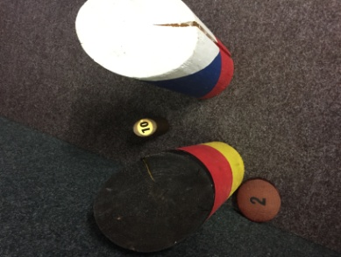
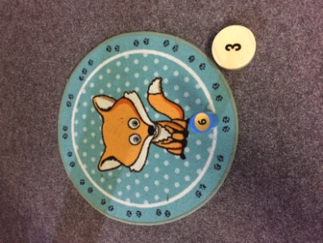
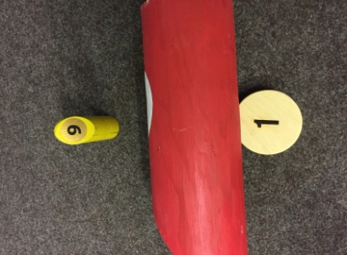

4. Three oaks 5. Corridor 6. French window
